**Given an array which may contains duplicates. print all elements and their frequencies.**

**Student Name: Rahul Kumar Singh UID:19BCS8016**

**Branch:** CSE **Section/Group:**18CSE20-A

**Semester:** 5th  **Date of Performance:**06-08-2020

**Subject Name:** DESIGN & ANALYSIS OF ALGORITHMS LAB **Subject Code:**CSP-309

**1. Aim/Overview of the practical:** Given an array which may contains duplicates.print all elements and their frequencies.

**2. Task to be done/ Which logistics used:**

To print all elements with their frequencies in array

**3. Algorithm/Flowchart (For programming based labs):**

**Step:1 Reduce all element by 1.**

**Step:2 For i = 0 to n-1, add n to element at index (input[i]%n).**

**Step:3 Print all count of i+1 as input[i]/n. set input[i] = input[i]%n+1.**

**4. Steps for experiment/practical/Code:**

import collections

list = [10,10,20,30,30,40,40,50]

print("Original List : ",list)

count = collections.Counter(list)

print("Frequency of the elements : ",count)

**5. Observations/Discussions/ Complexity Analysis:**

Using this we get complexity in O(n).

Using nested we get complexity O(n2).

**6. Result/Output/Writing Summary:**

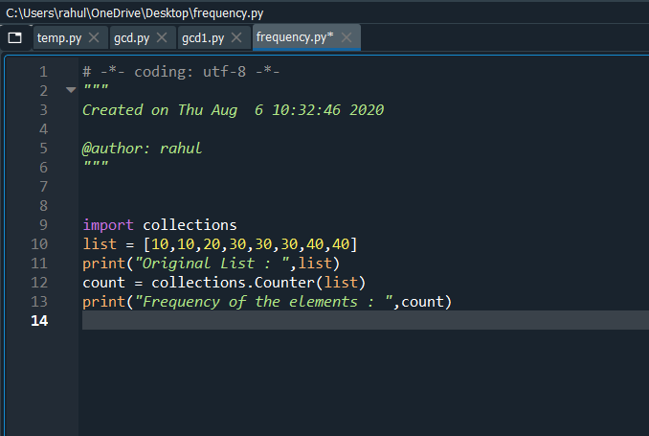

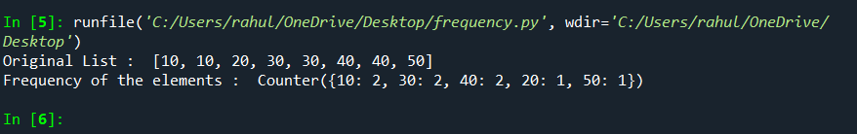

**Learning outcomes (What I have learnt):**

**1.**I have learn that how to count frequency of number**.**

**2.** It will take O(n) time complexity .